Failed to Lock the file from VMware Server

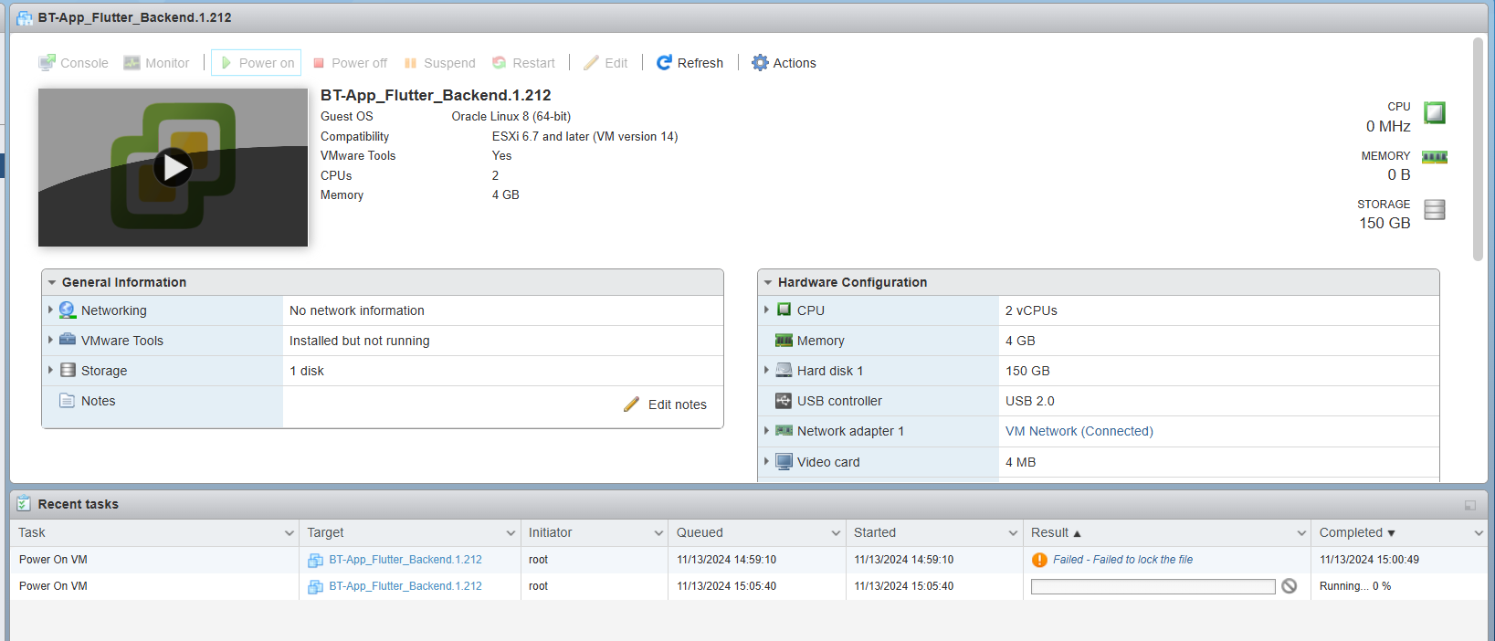

lsof |grep <lock file>

# lsof |grep <BT-App_Flutter_Backend.1.212.vmx.lck>

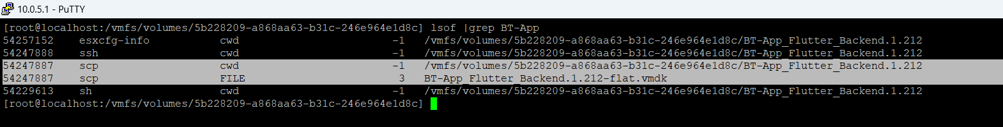

After checking Output will show the process wit PID then we need to kill the PID

# Kill -9 PID ( 54247007 )

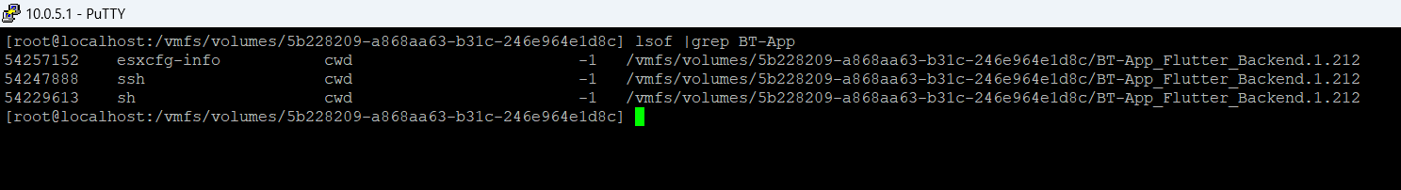

Then you can switch On the VM Server. It will run